APRIL 18, 2026

AYUSHMAN SETHY



Digital Elevator Control System Design using Solid-
State Logic

Abstract
The Smart Elevator Control System is a comprehensive digital logic-based project meticulously designed to simulate the intricate workings of an automated vertical transportation system. The primary objective of this architecture is to efficiently process discrete floor requests, logically
determine the required direction of spatial movement, and visually output the current floor utilizing purely digital circuitry. Implemented entirely within the Proteus simulation environment, the design relies on fundamental digital electronic components, notably including counters, comparators, combinational logic gates, sequential flip-flops, and decoders. By utilizing an IC 74191 counter to
track spatial positioning, an IC 7485 comparator to evaluate user input against current states, and 7-segment displays for immediate visual feedback, the elevator is capable of moving up or down based strictly on user input and Boolean logic conditions. Ultimately, this project serves as a highly practical demonstration of how foundational digital electronics can be applied to conceptualize and design robust, real-world control mechanisms.

Introduction
Elevators are an indispensable component of modern urban infrastructure, providing safe and efficient vertical transportation within multi-story complexes. At the heart of these transportation mechanisms lies a sophisticated control system tasked with managing simultaneous floor requests, calculating the most efficient direction of movement, and ensuring uncompromisingly safe
operational parameters.
This project report presents the complete design, architecture, and simulation of a Smart Elevator Control System built entirely upon digital logic circuits and simulated within the Proteus software environment. In contrast to contemporary microcontroller-based or microprocessor-driven
architectures (which rely on software programming), this design intentionally leverages fundamental, hardware-based digital components. This constraint makes the project highly educational, as it forces a "first-principles" approach to system design. The resulting system effectively illustrates how
fundamental digital logic and binary state machines can be utilized to execute complex decision-making processes analogous to those found in commercial elevator systems.

Theoretical Background
The foundation of this system is deeply rooted in digital electronics, utilizing both combinational logic (where the output depends solely on current inputs) and sequential logic (where the output depends on current inputs and past states). The core hardware components integrated into this simulation include:

Combinational Logic Gates
Logic gates serve as the fundamental building blocks for control operations and conditional routing:
    - AND Gate: Utilized for strict condition checking, ensuring multiple criteria are met before a signal propagates.

    - OR Gate: Employed for signal combining, allowing alternate pathways to trigger a unified response.
    - NOT Gate: Used for signal inversion, crucial for generating complementary signals within the control logic.

Integrated Circuits (ICs)
    - Positional Tracker (IC 74191): This 4-bit synchronous up/down counter serves as the core tracking mechanism for the elevator's current floor. The logic is configured such that the counter increments to simulate upward (UP) movement and decrements to simulate downward (DOWN) movement.
    - Decision Hub (IC 7485): This 4-bit magnitude comparator is responsible for comparing the user's requested floor (Input B) against the elevator's current floor (Input A). The operational outputs are logically defined as:
      - If A < B, the system initiates an UP-movement signal.
      - If A > B, the system initiates a DOWN movement signal.
      - If A = B, the system initiates a STOP signal, indicating arrival.
    - Memory Storage (74LS174): This IC consists of Hex D-type flip-flops. They are integrated into the circuit to temporarily store the requested floor data. This sequential memory stage is critical for maintaining a stable input signal and preventing erratic system behaviour caused by switch bouncing or noise.
    - Visual Output (7447 Decoder & 7-Segment Display): The 7447 acts as a BCD (Binary Coded Decimal) to 7-segment decoder. It converts the binary state of the counter into a human-readable display format, directly driving the 7-segment display to provide a clear, real-time visual output of the elevator's current floor number.

System Architecture and Design
To manage the complexity of the task, the elevator control system is highly modularized, compartmentalized into distinct sub-sections to handle specific logical operations:
- Input Interface Section: Utilizing physical toggle switches, this section allows the user to definitively select their desired destination floor, injecting a raw binary input into the system.
- Data Retention (Memory Section): The raw input from the switches is routed through D-flip-flops, which latch and store the selected floor. This prevents transient noise and physical
switch instability from corrupting the system's logic state.
- Spatial Tracking (Counter Section): This subsystem continuously monitors, updates, and tracks the current vertical position of the simulated elevator car in real-time.
- Logical Evaluation (Comparator Section): By actively cross-referencing the stable input from the memory section with the dynamic output of the counter section, this module generates the necessary movement directives.

- Control Logic Network: A carefully arranged network of logic gates takes the output from the comparator to finalize the movement direction and govern the ultimate operational state of the motor/counter.
- User Interface (Display Section): This final stage provides user-facing feedback, actively outputting the numerical floor data
.

Operational Workflow
The sequential operation of the system follows a deterministic, multi-step algorithmic flow:
- User Interfacing (Floor Selection): The sequence begins when a user selects a desired floor utilizing the input switches.
- State Latching (Storage): The transient switch input is immediately captured, stabilized, and stored within the flip-flop memory registers.
- Real-Time Evaluation (Comparison): The IC 7485 comparator continuously cross-examines the newly requested floor against the elevator's current recorded position.
- Kinematic Resolution (Movement Decision): Based on the comparator's output, directional logic is triggered:
  - If the current floor is mathematically less than the requested floor, an UP directive is issued.
  - If the current floor is mathematically greater than the requested floor, a DOWN directive is issued.
  - If the values are equal, the system generates a STOP command.
- Positional Update (Counter Increment/Decrement): Acting upon the movement directive, the IC 74191 counter dynamically steps its value up or down.
- Visual Confirmation (Display): The updated current floor value is instantly processed by the decoder and shown on the 7-segment display for the user.

Simulation and Implementation
The conceptual theoretical design was successfully transitioned into a functional, verifiable model using Proteus simulation software. To accurately replicate the electrical environment of a tangible
elevator system, all digital components, clock sources, and power rails were virtually interconnected.
During rigorous testing phases, binary switches were manipulated to simulate user floor selection. The simulation confirmed that the comparator logic accurately processed these requests, generated the correct movement direction signals, and subsequently triggered the counter to update the floor position in a controlled, step-by-step manner. The accompanying simulation diagram showcases the exact wiring of the logic gates (AND/OR/NOT), the 74LS174 storage module, the 74191 counter, the 74LS85 comparator, and the dual 7447 display drivers operating in unison.

Relying entirely on a software-based simulation afforded significant engineering advantages. It
allowed for rapid prototyping, isolated logic testing, easy debugging, and the validation of complex Boolean results without the overhead, cost, or physical risks associated with hardware
implementation.
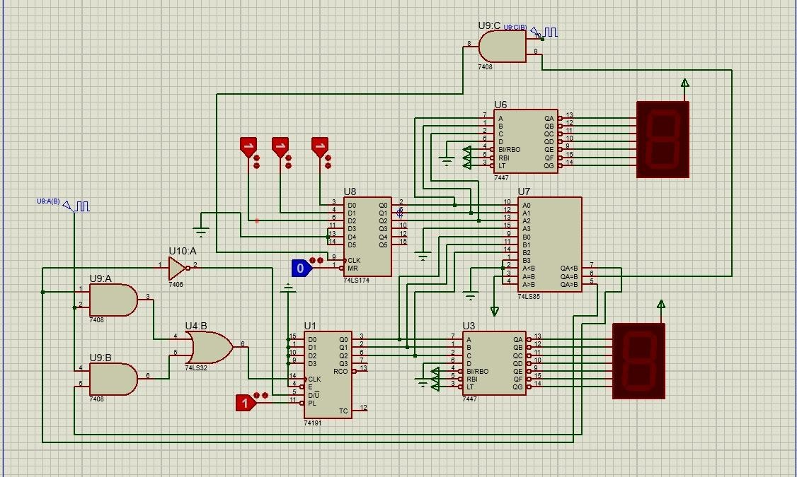

Results and Project Evaluation

Key Observations
The finalized simulation yielded highly successful results across all critical operational parameters:
    - Positional Accuracy: The system demonstrated flawless and accurate floor tracking.
    - Logical Integrity: The comparator effectively generated the correct movement direction under all tested permutations.
    - Interface Reliability: The system provided proper, glitch-free display output corresponding to the counter's state.
    - Overall Stability: The integration of memory flip-flops ensured highly reliable system behaviour, immune to simulated input noise.

Advantages
The current system architecture is notably advantageous due to its accessibility. It is highly cost-
effective and exceptionally easy to implement, primarily because it requires no physical hardware or expensive microcontrollers. Furthermore, it serves as a robust educational platform for
understanding digital state machines.

Limitations
The primary constraint of this project is that it is currently restricted to a virtual simulation. Consequently, it lacks the complex real-world physics and motor dynamics required for physical actuation. Furthermore, compared to modern software-driven elevators, this purely hardware-logic approach possesses limited functionality.

Future Scope
Future iterations of this project hold significant potential for expansion:
    - Hardware Realization: Transitioning the simulation to a physical PCB implementation with real logic ICs.
    - Algorithm Expansion: Upgrading the logic network to handle a complex, multi-floor request system.
    - Modernization: Introducing microcontroller integration (e.g., Arduino or ARM Cortex) to manage advanced control features such as door timers, weight sensors, and emergency override protocols.

Conclusion
The Smart Elevator Control System unequivocally demonstrates how fundamental digital logic circuits can be architected to simulate and manage complex, real-world control systems. By
seamlessly integrating combinational and sequential logic, the system efficiently processes variable user inputs, logically determines the optimal direction of travel, and reliably displays the resulting positional output. Ultimately, this project bridges the gap between theoretical digital electronics and practical engineering, providing a strong foundation for understanding industrial automation
systems.

